S. C. I

World

Quarterly Newsletter of the Joseph Groh Foundation
Summer 2016

News Bytes
2016 Dallas Golf Tournament Sets New Records

The day started out with a thunderstorm at about 3 AM – but that did not prove to be ominous for the tournament. While it was a bit overcast and cool, the 2016 Dallas golf tournament set records in every category! On May 2nd, 132 golfers showed up to enjoy a fun day and support the foundation. When all was said and done, over $57,000 gross was raised to help individuals with a connection to the construction trades who are living with a life altering disability. Part of this was raised by the silent auction, which also was a record. The board wants to sincerely thank all of the golfers and sponsors of the tournament for their continued loyalty and generosity! Be sure to visit the website Dallas golf page or foundation Facebook page to see photos from the event. A list of all the sponsors is shown below.

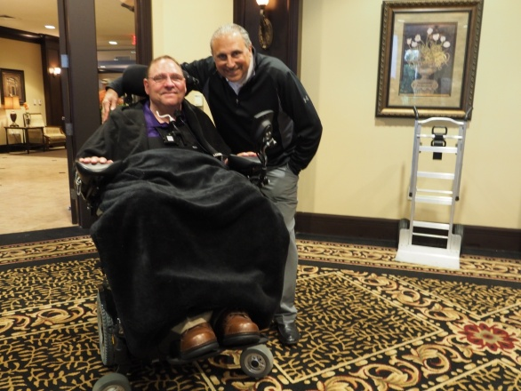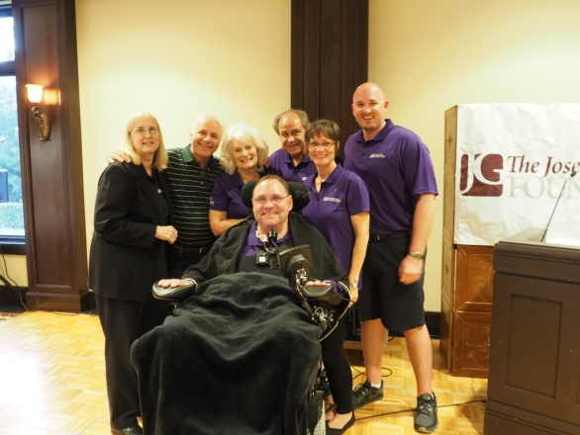
Title Sponsor Scott Boxer Foundation board of directors (L-R)
(Service Experts) with Joe Groh – Sue Groh, Mike Hajduk, Vicki Laplant,
who had trouble staying warm! John Laplant, Sue Huckabee, Eric
Groh (Missing – David Heimer)

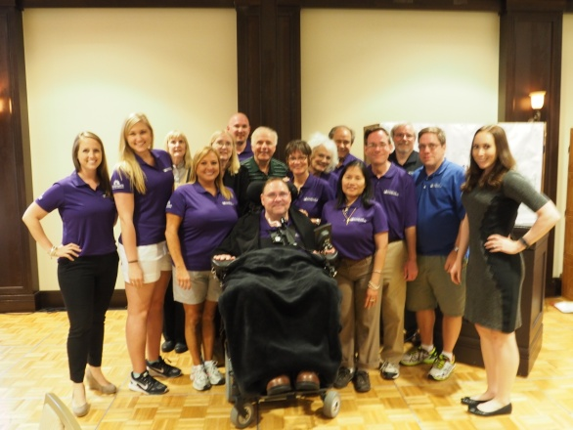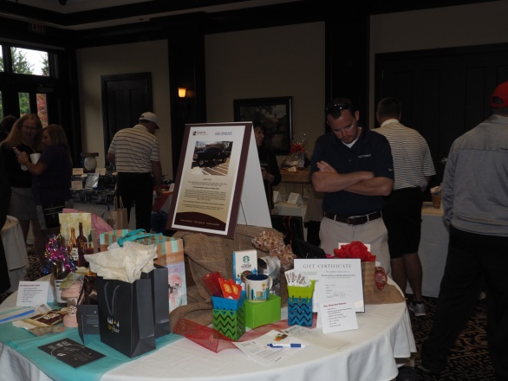
Volunteers who work behind the Golfers browse the silent auction,
scenes to make everything happen scouting for bargains

Thanks to all the sponsors, golfers, and donors who made this day possible!

Many thanks to our hole sponsors that day!

Home Warranty of America Matt Groh Wayne Atkins George Groh
Bob & Sue Huckabee Profit Rhino Bill Joplin’s AC/Heating
Selling Trust IMS Advertising Dr. Kirk Cooper
Anthony International Sterling HVAC Charley Greer
Contractor 20/20 Industrial Controls Central Messaging

Golfball SponsorMarianne McKinley & The Newsletter Company

Upcoming Golf Tournaments

The foundation plans has 2 more golf tournaments on tap in 2016 – Barrington, Illinois (Chicagoland area) and Ramsey, Minnesota. (Minneapolis) As more and more people find out about the work of the foundation and apply for grants, the foundation is seeking new ways to bring individuals together in a way that is funraising! Thus far in 2016, the foundation has provided 4 grants and is in the midst of funding 3 more. At present, there are 14 additional qualified applicants awaiting funding, so we welcome sponsors and golfers to our 3rd annual Chicago and first ever Minneapolis tournaments! See website specific sign-up pages for more information.

Makray Memorial Golf Club The Links at North Fork
Barrington, Illinois Ramsey, Minnesota
Monday, August 29, 2016 Monday, September 12, 2016

ServiceTitan Promotion Raises $10,000 for Foundation

Software leader ServiceTitan held a promotion in April and May, 2016 to benefit the Joseph Groh foundation, raising $10,000 in the process! In actuality, there were two promotions which ran during this timeframe for the foundation. The first featured a $1000 donation for every Service Roundtable member who signed up for a software package, and the second pledged a $1000 donation for every referral that led to the purchase of a software package. In both cases, ServiceTitan also offered the purchasing contractor a $1000 savings off their Customer Success Package!

The Service Roundtable is an industry best practice organization for HVAC, electrical, solar, and plumbing contractors. They have chosen the Joseph Groh Foundation as their official foundation.

ServiceTitan was started in 2012 to help the underserved home services industry better manage their businesses, improve sales and provide an extraordinary customer experience. They accomplish this with a software platform that helps contractors monitor call booking performance, track technician sales performance, and measure the impact of marketing campaigns while eliminating costly and time-consuming paperwork. This powerful, yet easy to use software combines scheduling, dispatch, invoicing, sales, marketing, reporting and more… all in a mobile, cloud-based platform. Their software is used by such well-known companies as Mr. Rooter, Baker Brothers Plumbing and Air-Conditioning, Hunter Heat & Air, Mr. Electric and many others.

Our thanks to both ServiceTitan and the participating contractors who made it possible!

Service World Expo

Attention residential HVAC contractors, if you haven’t heard, Service Nation Inc. has joined forces with the ACHR News, Plumbing and Mechanical Magazine, and Reeves Journal to launch the first new conference and tradeshow in more than 2 decades! This innovative and engaging event is focused on cutting edge products, services and new speakers, all delivered in a groundbreaking format. Four speakers will highlight the main stage while another four will pace the Leadership and Management Lane. There will also be four speakers each driving the Sales Lane, Business Development Lane and Marketing Lane. The event is scheduled for October 26-27, 2016 at the Tropicana Las Vegas. Perhaps the best news of all is that the Joseph Groh Foundation will have booth #45 at the Product Showcase exhibits! Okay, perhaps that’s a bit overstated, but we are excited about it. At the foundation booth, visitors will have the opportunity to pledge donations for a specific, but as of yet unfunded grant applicant. Donations pledged at the show will be matched by the foundation, and it is our hope that between the 2, yet another grant applicant will have their request funded. For more information, see www.serviceworldExpo.com.

Foundation to Launch New Initiative

The Joseph Groh foundation was launched to accomplish 3 objectives.
1. Serve as a clearinghouse of information for those living with life altering disabilities
2. Provide financial assistance to those with a connection to the construction trades who are also living with a life altering disability
3. Encourage companies to offer and employees to sign up for short and long-term disability insurance

Up to now, the foundation has only been actively in pursuit of the first 2 objectives, but that will change in 2017! Consider the following:
A major disability is something that happens to someone else… Until it doesn’t! The sad fact is most Americans are better prepared to die than they are to deal with disabilities. Just over 1 in 4 of today’s 20-year-olds will become disabled before they retire. In fact, over 37,000,000 Americans or about 12% of the total population are classified as disabled, and 8,800,000 wage earners are receiving Social Security disability insurance. (2.5 million of these are in their twenties, thirties and forties)

How well are Americans prepared to handle a disability? Woefully prepared! 48% of US families do not save any of their annual income, and 1/3 of working families have no retirement savings. Given this, 68% of adult Americans have no savings earmarked for emergencies and 65% of working Americans say they could not cover normal living expenses for one year if their employment income was lost. The Joseph Groh foundation is committed to doing something about these unacceptable statistics, stay tuned for more information about our 2017 initiative!

May, 2008 at our son’s college graduation June, 2008 At Baylor Rehab
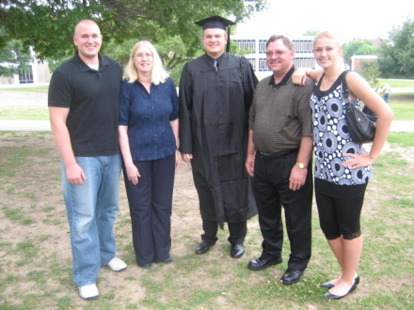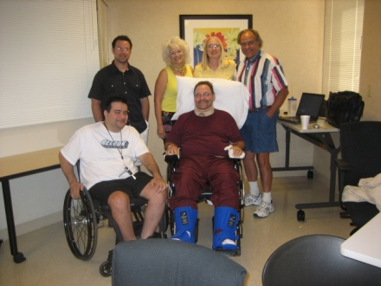

A major disability is something that happens to someone else… Until it doesn’t!

Featured on the Website

Recent Changes to the Foundation Website

- Homepage
  - Upcoming events, updated sponsor list and new stories
- News Page
  - Summer 2016 Newsletter
  - Archived News Articles and Newsletters
- Links Page – New Links Added
  - Home adaptions for individuals with disabilities – Under Caregiver Help and Assistance
  - Center for Neuro- Recovery in North Palm Beach, Florida – Under Rehabilitation Facilities
  - A College Guide for Students with Disabilities – Under National Resources
  - New Category Added – Pain Management
    - Resource Guide to Chronic Pain Management
    - Facts about Chronic Pain And Disability
    - Pain Management and Opioid Abuse
    - The 45 Warning Signs of Prescription Drug Abuse
    - When Pain Accompanies Depression
    - Relieving Pain with Anti-Inflammatory Diets
    - How Healthy Sleeping Habits Can Reduce Chronic Pain

There are now 172 websites referenced on our links page, we invite you to pass the word about this incredible and growing resource!

Amberly Snyder – A Person You Should Know

Amberly Snyder’s passion for horses began when she was 3 years old and taking weekly riding lessons. She decided to leave horseback riding however for other sports hobbies due to frustrations about her legs being too short to pass the saddle pad so she could kick the horse to go faster. As she grew she decided to go back to riding. Even though her home state of California did not have rodeo competitions, she would take her pony out and set up cones in order to do her own barrel patterns. At the age of 7, her family moved to Utah where her dad, a professional baseball player, got her a barrel horse. Rodeo became a huge passion from then on and has stuck with her ever sense. All this was challenged however on January 10, 2010 when Amberly was in a car accident.

Heading to Denver for his talk show, Amberly was driving through Wyoming when she looked down to check her map. As she looked up, she realized she had faded over a lane and was headed toward a metal beam on the side of the road. She grabbed the wheel and the tail end of the truck started sliding out. As she tried to correct the slide, the truck went off the road completely sideways. “I remember thinking that this was not going to end well as I felt the truck pick up off the ground and begin to roll,” she said. When the rolling ended, Amberly opened her eyes and found herself sitting in a snow bank on the side of the freeway. She had hit a fence post across her stomach, which broke her back. While able to move her fingers, she did not have any feeling in her legs. She underwent 5 hours of surgery which left her with hardware in her back. Amberly rehabbed at Utah Valley Hospital in Provo, where doctors told her she would not gain feeling below her waist or regain mobility in her legs.

Amberly was determined to get back on her horse following the accident, but when she did for the first time the realization is not what people would expect. Amberly came face to face with the realization that life was not going to be the same, and that she would have to deal with this moving forward. She decided to take a break from writing and went to college to fill the void that riding left in her heart. About one year later she was contacted by a newspaper who wanted to take photos of her on her horse. By this time Amberly’s mindset was different as she was more accustomed to the changes in her life. When she got on her horse, she experienced an unforgettable feeling, and that was she was not going to give up writing. She convinced her therapists to let her bring a saddle into therapy where she learned to gain her balance. She used a seat belt around her waist, Velcro for her legs and stirrups and a nylon strap to keep her from moving around during barrel turns. Making small goals and accomplishing them, she would then set new goals that were more audacious. Within a few months she convinced her doctors and parents to allow her to ride again.

Since then she has won over 60 buckles and 7 saddle competitions, and in 2009 was in the finals in the World All-Around Cowgirl of the Little Britches Association. She continues to ride and competes in the Pro rodeo circuit. She plans to graduate with her Bachelors in Agricultural Education And Masters in School Counseling. Amberly says that when you get back to what you love, you have the opportunity to inspire others because of the situation you are in. Amberly advises that your attitude can either be your biggest obstacle or your greatest strength – you just have to decide which one it will be.

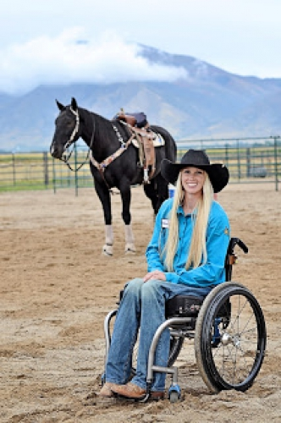
Amberly Snyder and her horse, Power

A Day in the Life

This feature is a sometimes humorous, sometimes offbeat, and sometimes irreverent look at life as seen through the eyes of a severely disabled person. Management takes no responsibility for these ramblings.

Skinnywiggle
There are all kinds of expressions to describe the narrowest of margins. Some of these include:
- squeak by
- by a nose
- by a whisker
- skinnywiggle
- my grades in high school
Okay, the last one is a joke (really, it is) and you may not have heard of the second to last one, but all these and more provide a mental picture of narrow margins or tight spaces. I sometimes think the creators of ADA specifications think in such dimensions. As you read through the ADA standards, you come across what I call “weasel clauses.” Those are ones which allow those constructing public spaces to skinnywiggle on some of the requirements.
For example, the standards under new building construction allow for “exceptions for structural impracticality.” What is that you ask? Well, to quote the standard, “Full compliance with the requirements of this section is not required where an entity can demonstrate that it is structurally impractical to meet the requirements.” Wait, aren’t we talking about new construction? That would mean nothing had been built yet. So what if it is structurally impractical to meet the requirement? Then, “If full compliance with this section would be structurally impractical, compliance with this section is required to the extent that it is not structurally impractical.” Wait, what? Perhaps this was will clear everything up for you. “If providing accessibility in conformance with this section to individuals with certain disabilities (e.g. those who use wheelchairs) would be structurally impractical, accessibility shall nonetheless be insured to persons with other types of disabilities.” Okay, I get it. If you have an area – say the entrance to your building – declared structurally impractical, you only have to build it in such a way that only those who are blind or deaf can get through. That makes sense, I have seen such places!
Another such clause can be found in the section of the standard that talks about alterations affecting the path of travel. The standard states that “an alteration that affects or could affect the usability of or access to an area of a facility that contains a primary function shall be made so as to ensure that, to the maximum extent feasible, the path of travel to the altered area in the restrooms, telephones, and drinking fountains serving the altered area are readily accessible to and usable by individuals with disabilities, including individuals who use wheelchairs.” That all sounds great except for the part I left off, which reads “unless the cost and scope of such alterations is disproportionate to the cost of the overall alteration.” Hmmmmm.
Let’s go back to doorways for a specific example. According to ADA, an adult size wheelchair has a width of 26 inches measured to the outside of the rear wheels. Doorways must be a minimum of 32 inches wide as measured between the face of the door and the opposite stop. Great, no problem you say. There’s only one problem – my wheelchair is 33 inches wide! Well, you are the exception you say. I say, thank you for recognizing me as exceptional! In reality, most wheelchairs aren’t as big as mine. That is not much consolation however when you are trying to skinnywiggle through a narrow door. The special ones are those double doors that really aren’t, because of the center post that only becomes visible when you open the doors. The really special ones are the same kind of doors that also have the push bars, because the hardware is in the allowable width, thereby narrowing the door even more!
How do we overcome these types of doors? The answer is, it depends. As long as the threshold isn’t too high, (a whole nuther story) we will move my arm off the arm rest and adjust it to another position. I have to be careful however so that my arm doesn’t get wrenched, which could break it. If it is a place that I have to frequent by necessity such as a doctor’s office, we take our time going through and usually make mention of it to the receptionist. (Which does absolutely no good, but it makes us feel good) Hopefully, no one is waiting for us to get through who has a weak bladder! If it is not a place I have to frequent such as a restaurant for example, we go somewhere else.
I have an idea for the writers of ADA regulations. I think the next revision of the ADA standard needs to provide the following verbiage. “If there is a line to get in to an establishment, Joe Groh will move to the back of the line. In addition, in the event of a fire, Joe Groh shall be evacuated last.” That would make me sleep better at night, knowing that I would not be the cause of all those people failing to make it out during a fire – or wetting their pants!

This is why I should go last!

